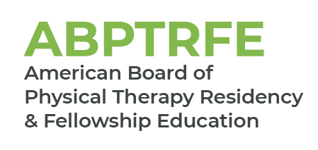
Medical Conditions – Pediatrics
For Renewal of Accreditation and ACIR

Please complete the chart below by filling in the medical conditions seen by the resident over the course of the program. Patients evaluated, treated, or managed by the resident as part of the resident’s education throughout the course of the program should be included within the template.

The patient’s medical condition is only counted during the first patient encounter. Patient encounters beyond the initial visit should not be included in the frequency count.

Name of Graduate:
Medical Conditions  Pediatrics | Number of Patients Evaluated, Treated, or Managed by the Resident as Part of the Program’s Curriculum
Cardiovascular System
Congenital heart defects (e.g., atrial septal defect, tetralogy of Fallot, heart transplant)
Neonatal cardiovascular conditions
Pulmonary System
Asthma
Cystic fibrosis
Neonatal pulmonary conditions (e.g., bronchopulmonary dysplasia)
Sequelae of long-term ventilator use
Integumentary System
Burns
Prevention of tissue breakdown
Wounds
Nervous System
Anoxic events
Autism spectrum disorders
Cerebral palsy (e.g., hypotonic, hemiplegic, quadriplegic, tetraplegic, diplegic)
Cerebral vascular accident
Developmental coordination disorders
Developmental disabilities
Inflammatory and infectious disorders of the central nervous system
Intracranial hemorrhage
Peripheral nervous system injuries (e.g., brachial plexus injuries)
Sensory processing disorders
Spinal cord injury
Musculoskeletal System
Arthrogryposis
Congenital / traumatic limb deficiencies
Fractures
Hypotonia / hypermobility leading to joint injury
Juvenile idiopathic arthritis and other arthritic diseases
Musculoskeletal injury and pain due to sports injuries in children (e.g., Osgood Schlatter, overuse injuries, joint injuries, growth plate injuries, limb injuries)
Osteogenesis imperfecta
Osteopenia
Spinal conditions
Spinal malalignments including scoliosis / kyphosis / lordosis
Torticollis / Plagiocephaly
Other orthopedic conditions (e.g., Legg-Calve-Perthes, slipped capital femoral epiphysis, tibia varum, skeletal dysplasia, osteosarcoma-limb salvage)
Involvement Of Multiple Systems
Complications of prematurity (e.g., osteopenia, respiratory distress syndrome, intraventricular hemorrhage, bronchopulmonary dysplasia, high risk infant)
Complete trisomy 21 syndrome (Down’s syndrome)
Developmental delay/disabilities
Genetic syndromes (eg, Pradi Willi, hemophilia)
Hematological conditions
Idiopathic toe walking
Malignant neoplastic disease and oncological disorders (cancers)
Malnutrition / failure to thrive
Metabolic disorders (e.g., diabetes, mitochondrial disorders)
Muscular dystrophy and neuromuscular conditions (e.g., Duchenne, Becker, spinal muscular atrophy)
Myelodysplasia (e.g., spina bifida, Arnold-Chiari, hydrocephalus)
Obesity
Pain syndromes
Rett syndrome
Other
Insert additional conditions not reflected above

