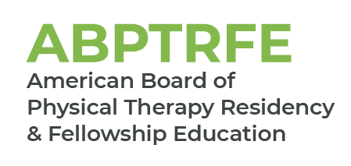
Medical Conditions – Neurologic Movement Disorders
For Renewal of Accreditation and ACIR

Please complete the chart below by filling in the medical conditions seen by the fellow over the course of the program. Patients evaluated, treated, or managed by the fellow as part of the fellow’s education throughout the course of the program should be included within the template.

The patient’s primary medical condition is only counted during the first patient encounter. Patient encounters beyond the initial visit should not be included in the frequency count.

Name of Graduate:
Medical Conditions  Neurologic Movement Disorders | Number of Patients Evaluated, Treated, or Managed by the Fellow as Part of the Program’s Curriculum
Nervous System
Ataxic disorders
Chorea and Huntington’s disease
Parkinson’s disease
Tics and Tourette syndrome
Tremor and Essential tremor
Other
Insert additional conditions not reflected above

